Library Name: | cgm
Cell Name: | AOI3
Function/Truth Table: Y = $\overline{(B+C).A}$
A B C |  | Y
0 0 0 |  | 1
0 0 1 |  | 1
0 1 0 |  | 1
0 1 1 |  | 1
1 0 0 |  | 1
1 0 1 |  | 0
1 1 0 |  | 0
1 1 1 |  | 0
Propagation Delay (path based):
Transition |  | Delay (s)
A → Y ↑ (T_PLH) |  | 1.25n
A → Y ↓ (T_PHL) |  | 1.326n
B → Y ↑ (T_PLH) |  | 1.397n
B → Y ↓ (T_PHL) |  | 1.633n
C → Y ↑ (T_PLH) |  | 1.369n
C → Y ↓ (T_PHL) |  | 1.682n
Output Rise Time (path based):
Transition |  | Rise Time (s)
A → Y ↑ |  | 2.484n
B → Y ↑ |  | 2.679n
C → Y ↑ |  | 2.652n
Output Fall Time (path based):
Transition |  | Fall Time (s)
A → Y ↓ |  | 2.457n
B → Y ↓ |  | 3.104n
C → Y ↓ |  | 3.234n
Layout Height: 1.71µm
Layout Width: 1µm
Layout Area: 1.71µm²
Symbol with Port Names:

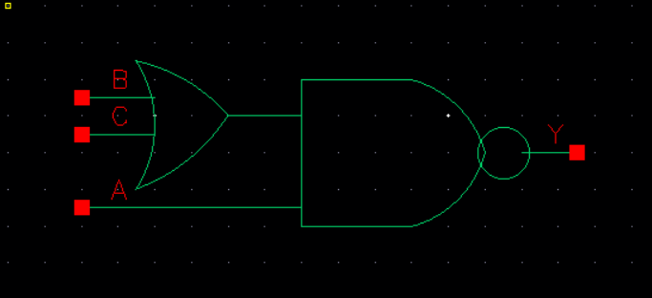
Schematic:

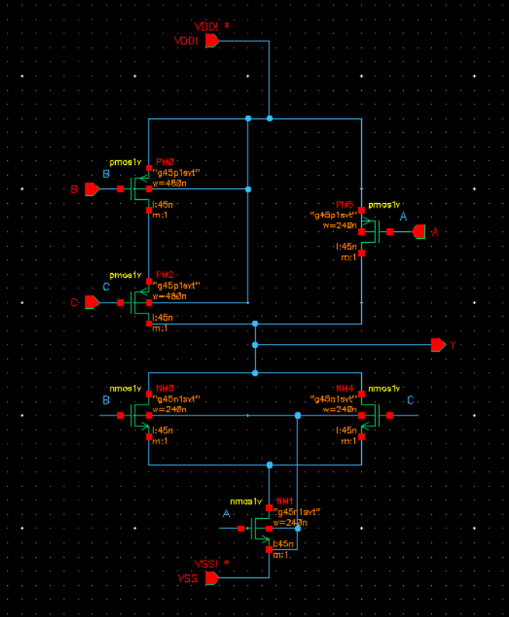
Layout:

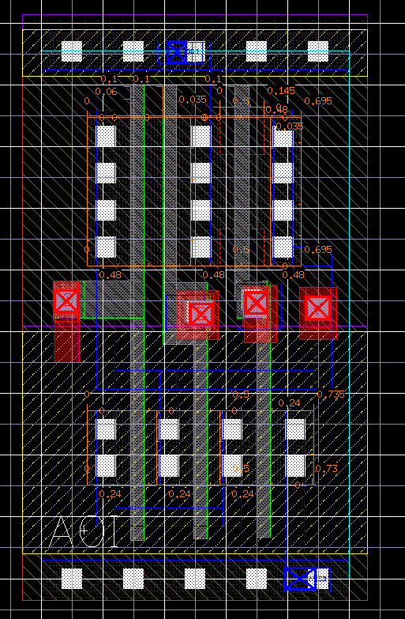
Functional Simulation Waveforms

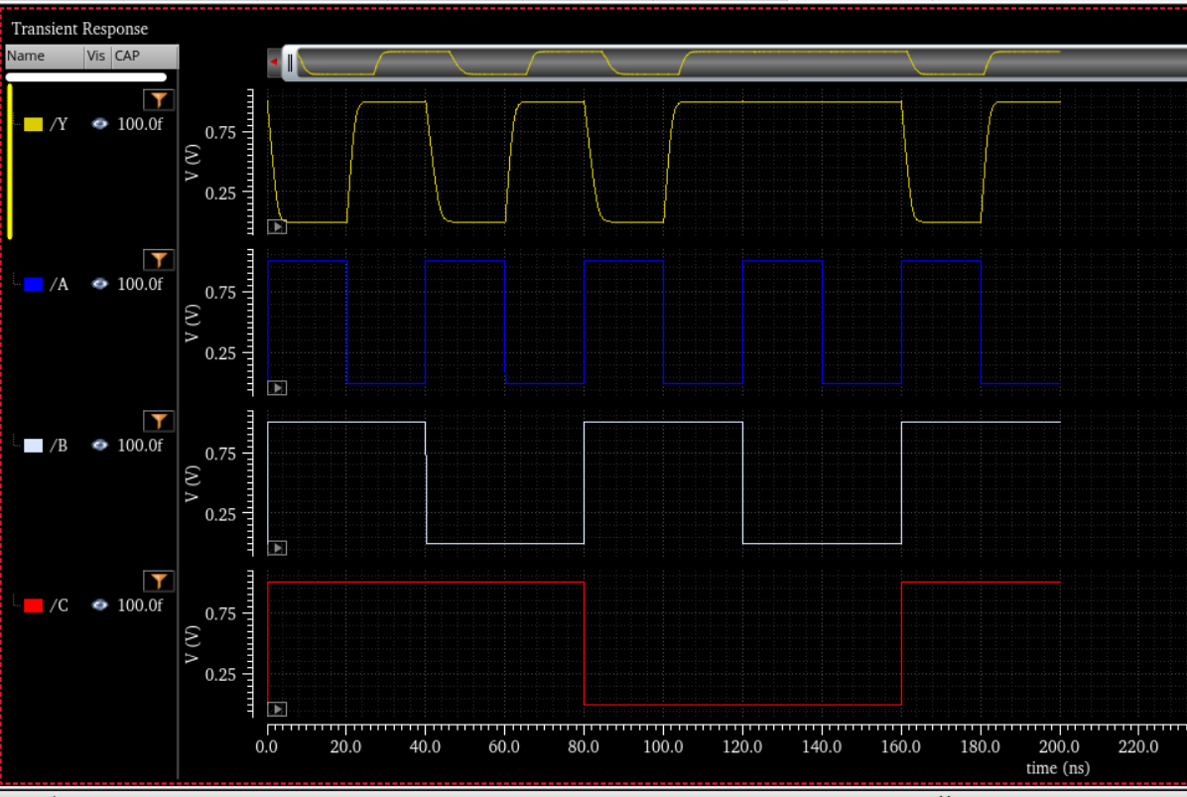

Comments/Notes:

The AOI3 (AND-OR-INVERT) gate was successfully tested, confirming correct functional verification. The extracted parasitics have impacted timing, with rise times increasing compared to the pre-layout results, while fall times have improved. This behavior is due to the influence of parasitic capacitances and resistances in the extracted layout, which affect the charge and discharge paths differently. Despite these variations, the gate meets expected performance requirements and remains functionally accurate.

